Look at the book covers and answer the following questions. There may be several good answers.
You can do this activity on line: https://learningapps.org/watch?v=pp8spu9dn21

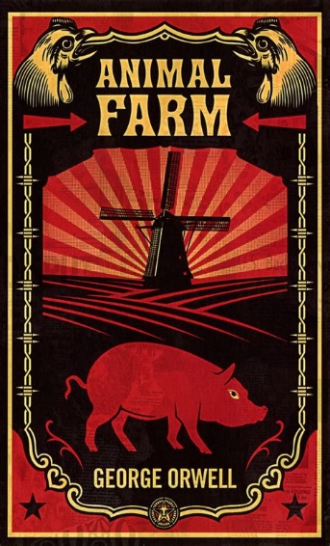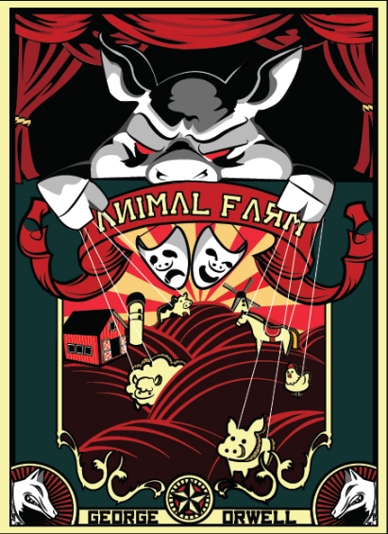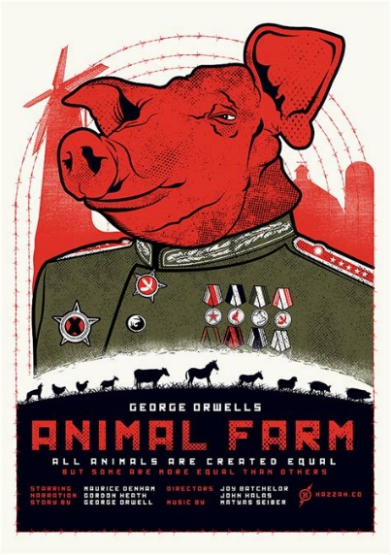

The main characters of the book are…
The story looks like a…
☐horror story ☐love story
In the second picture the pig looks…
☐frightening ☐intelligent ☐mean
In the third picture the pig looks like…
☐a military hero ☐a leader ☐a prisoner

☐farmers ☐animals
The hero of the story is…
☐ a pig ☐a horse
The story is for…
☐children ☐adults
The dominant colour in the book covers is…
☐red ☐blue
It symbolises…
☐violence and blood ☐love ☐communism

Read this back cover blurb to discover what the book is about.
‘ALL ANIMALS ARE EQUAL. BUT SOME ARE MORE EQUAL THAN OTHERS.’
Mr. Jones of Manor Farm is so lazy and drunken that one day he forgets to feed his livestock.
The ensuing rebellion under the leadership of the pigs Napoleon and Snowball leads to the animals taking over the farm. Vowing to eliminate the terrible inequities of the farmyard, the renamed Animal Farm is organized to benefit all who walk on four legs. But as time passes, the ideals of the rebellion are corrupted, then forgotten. And something new and unexpected emerges...
Animal Farm – the history of a revolution that went wrong – is Orwell’s brilliant satire on the corrupting influence of power.

You can watch that short video about the book: https://youtu.be/rh3fbyupE2c

George Orwell (1903 - 1950)
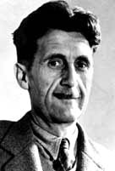
Orwell was a British journalist and author, who wrote two of the most famous novels of the 20th century 'Animal Farm' and 'Nineteen Eighty-Four'.
Orwell was born Eric Arthur Blair on 25 June 1903 in India, which was then a British colony, the son of a British colonial civil servant. He was educated in England and, after he left Eton, joined the Indian Imperial Police in Burma, then a British colony. He resigned in 1927 and decided to become a writer. In 1928, he moved to Paris where lack of success as a writer forced him into a series of menial jobs. He also experienced homelessness. He described his experiences in his first book, 'Down and Out in Paris and London', published in 1933. He took the name George Orwell, shortly before its publication. This was followed by his first novel, 'Burmese Days', in 1934.
An anarchist in the late 1920s, by the 1930s he had begun to consider himself a socialist. In 1936, he was commissioned to write an account of poverty among unemployed miners in northern England, which resulted in 'The Road to Wigan Pier' (1937). Late in 1936, Orwell travelled to Spain to fight for the Republicans against Franco's Nationalists. He was forced to flee in fear of his life from Soviet-backed communists who were suppressing revolutionary socialist dissenters. After that he wrote 'Homage to Catalonia' (1938).The experience turned him into a lifelong anti-Stalinist.
Between 1941 and 1943, Orwell worked on propaganda for the BBC. In 1943, he became literary editor of the Tribune, a weekly left-wing magazine. By now he was a prolific journalist, writing articles, reviews and books.
In 1945, Orwell's 'Animal Farm' was published. A political fable set in a farmyard but based on Stalin's betrayal of the Russian Revolution, it made Orwell's name and ensured he was financially comfortable for the first time in his life. 'Nineteen Eighty-Four' was published four years later. Set in an imaginary totalitarian future, the book made a deep impression, with its title and many phrases - such as 'Big Brother is watching you', 'newspeak' and 'doublethink' - entering popular use. By now Orwell's health was deteriorating and he died of tuberculosis on 21 January 1950.
Read the text about George Orwell and complete the chart.
Childhood
birth • parents / family • education
The colonial police officer (1922-27)
places • experiences
The Defender of Working-class Life (1928-36) places • experiences • writings
Political Activist political ideas
events he took part in • actions • writings
Journalism (1941-50)
employers • famous subjects
Books
Death

Check your memory : https://learningapps.org/watch?v=ps1n4zfkk21

