

SOCIAL NETWORKING

Write the names of the social networks that correspond to each logo.

You can do this activity on line: https://learningapps.org/watch?v=p6henxc6j21

 |  |  |  |  | 

- Complete the following sentences with the names of these social networks.

You can do this activity on line: https://learningapps.org/watch?v=p41zbon7k21

_______________________ is a video-sharing focused social networking service. The social media platform is used to make a variety of short-form videos.

After registering, _______________________ users can create a profile revealing information about themselves. They can post text, photos and multimedia. Users can also communicate directly with each other, join common-interest groups, and receive notifications on the activities of their “friends” and pages they follow.

_______________________ is a photo and video sharing social networking service. The app allows users to upload media that can be organized by hashtags. Posts can be shared publicly or with pre-approved followers. Users can like photos and follow other users to add their content to a personal feed.
_______________________ is a multimedia instant messaging app and service. One of the principal features of_______________________ is that pictures and messages are usually only available for a short time before they become inaccessible to their recipients.

_______________________ is a microblogging and social networking service on which users post and interact with messages known as "tweets". Registered users can post, like, and retweet tweets, but unregistered users can only read those that are publicly available.

_______________________, is an instant messaging service. It allows users to send text messages and voice messages, make voice and video calls, and share images, documents, user locations, and other content. The service requires a cellular mobile telephone number to sign up.

How often do you use these social networks?
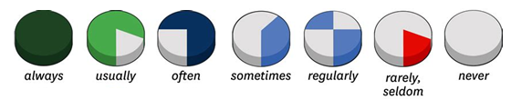

Facebook features

What can you do on Facebook?

Match the phrases(=expressions) on the left with their corresponding functions on the right:

- send a friend request a. chat with someone in real-time using text

- receive a friend request b. display a public message for your friends to read

- send a message c. give positive feedback about a comment

- tag someone d. label another person in a photo

- post a status update e. receive an invitation to be someone’s friend

- browse your news feed f. remove a friend from your friend list

- like a comment g. see what your friends are doing on their proﬁles

- unfriend somebody h. start a personal page (where you can include your pictures,
information about you, etc.)
- create a proﬁle i. try to connect with someone who is not in your friend list

Now complete the dialogue below using the phrases above in the correct grammatical form.

Paul: Do you use Facebook?
Julie: Yes, everyday.
Paul: What do you use it for?

Julie: Well, I like to know what my friends are doing all the time so I often ¹.
How about you?

Paul: I only ² about a year ago, and I haven’t used the site very much.
Julie: Why not?

Paul: Well, I lots of ³ from people I hardly know. I just don’t see the point of it.
Julie: Really? You don’t have to accept all of them. It’s great when you travel and you meet someone new. If you want to stay in touch, you can go on Facebook and ⁴. Of course, if the person becomes really annoying, you can always decide to ⁵ her.
Paul: Perhaps you’re right. But I also don’t like the idea that everybody knows what I’m doing in my life.
Julie: Well, you don’t have to ⁶ all the time. That way, your friends won’t see what you are doing on their proﬁle walls. But if you want to contact one of your friends, you can always ⁷. Only that friend will see your message.
Paul: I see.

Julie: Personally, I like it when my friends my ⁸. The comment appears in their friends’ news feeds.
Paul: Do you post pictures?

Julie: Yes, I always add new photos to my proﬁle. And my friends often ⁹ me in their pictures. It’s great

Uses of social networks

Watch the video of teenagers talking about their daily lives.

Cliquez ici pour visionner la video

Listen to Alejandra and list her different activities.

Listen to Sasha and list his different activities.

- Make a few sentences to underline the differences and the common points between Alejandra’s and Sasha’s talks with the help of the vocabulary box.

Vocabulary box :

• Both teenagers say that …
• Both (= Tous deux) like + V-ING (ex : playing / posting…)
• Alejandra uses [ju:z] her phone to + BV… whereas (= alors que/ tandis que) Sasha prefers to + BV…
•The two American teenagers don’t have a similar use [ju:s] of new technologies because…
• The two American teenagers agree that…
• His/ her favourite apps are… because they enable / allow ( = permettre) him/her to + BV…
• Unlike Alejandra, Sasha…. / Unlike Sasha, Alejandra … (utiliser un verbe conjugué à la 3ème personne du singulier au présent simple)

Writing task: What about you?

Before writing:

Step 1: Crosswords

Complete the grid below:

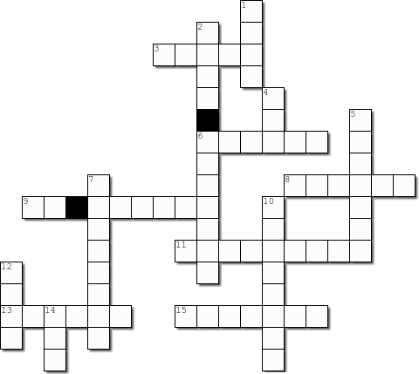
You can do it on line: https://learningapps.org/watch?v=pdg1aq0uj21
M
M
S
P
F
W
S
F
G
O
W
L
X
A D D
T
A V
P
B
H
D
P
G

Horizontal  3. Give a part of something  6. To watch the development of  - A photo of oneself  - Connect  11. Causing dependency  13. Image representing a person  15. Make public | Vertical  - Come together  - Get new companions  - Abbreviation for “in real life”  - Short presentation of a person  7. Transfer from the Internet to a computer  10. Stimulating  12. Have a discussion  14. Abbreviation for “application program”

Step 2: Revise your grammar: Le present simple

Les phrases suivantes sont conjuguées au présent simple. Complétez le tableau pour dire ce qu’elles expriment.

Mary is tall./ Water boils at 100°C./ She drinks coffee every morning./ I love jazz.

On emploie le présent simple pour… | Exemples

Parler de goûts

Parler de quelque chose qui est vrai de manière générale

Décrire quelque chose ou quelqu’un

Parler d’une habitude ou d’événements qui se répètent

Conjugaison : complétez les tableaux

 | Forme affirmative
 | play | kiss | push | fix | study | have
I, we, you, they | play
He, she, it | plays

 | Forme négative
 | play | study | have
I, we, you, they | Do not play  Don’t play
He, she, it | Does not play  Doesn’t play

 | Forme interrogative
 | play | study | have
I, we, you, they | Do you play?
He, she, it | …………… he play?

Revise your grammar and practise: les adverbes de fréquence

Observez les phrases suivantes et complétez la règle.

Young people never use Facebook.

I am very often connected on TikTok.

Les adverbes de fréquence se placent_________________________ le verbe mais __________________ le verbe Be.

Remettez les mots dans l’ordre pour former des phrases correctes.

my phone/never/ my mum/ let me/ use/ after dinner/.

you/ how often/ connected/ are/?

photos/ sometimes/ my brother/ posts/ on Instagram/.

Photos/ I/ always/post/ new / don’t /on my profile/.

Step 3: Let’s go!

Write a short paragraph about your own habits when it comes to social media.

To help you out, answer the questions and follow the guidelines:

How long do you spend online, on your smartphone/ tablet / laptop (= ordinateur portable)?

Élargissement lexical : habitudes et fréquence : usually • as a rule • almost always • tend to+ BV • (quite) often • every (single) day / minute… • sometimes • hardly ever (=presque jamais) • never • constantly • at all times • non-stop.

What do you on the Internet or on your favourite apps?

How do you feel about your habits?

Pour cela, pense à utiliser des adjectifs ainsi que des verbes et expressions de goût pour traduire tes impressions et sentiments.

